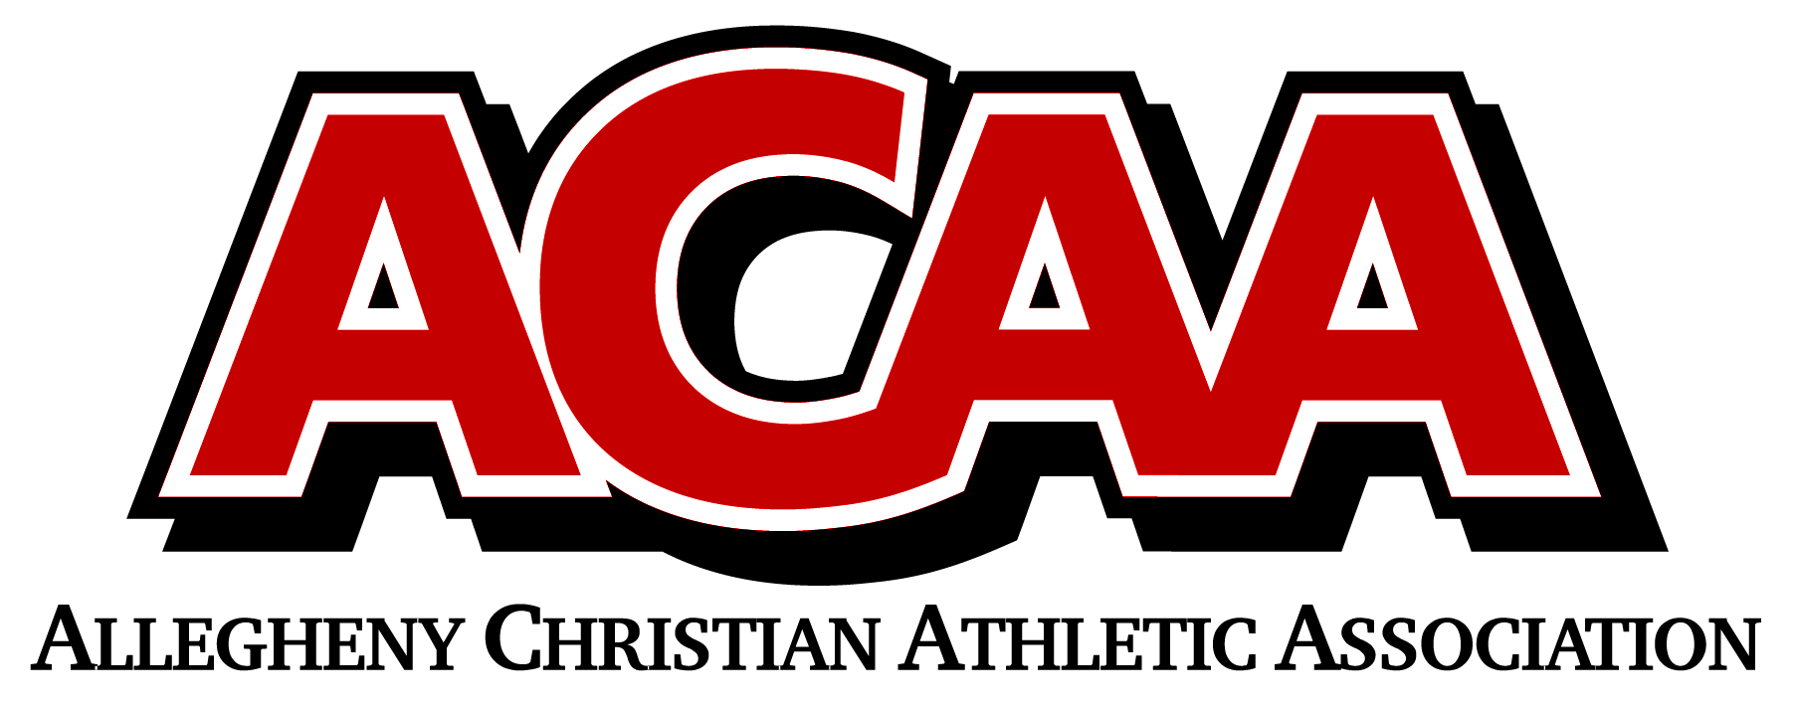

DIVISION ALIGNMENT 2023-2024

BASKETBALL
EASTERN DIVISION
# 1E | Grace Prep High School
# 2E | Juniata Christian School
# 3E | Columbia County Christian School
# 4E | Meadowbrook Christian School
# 5E | Belleville Mennonite School
# 6E | Northumberland Christian School
# 7E | BYE
# 8E | Walnut Street Christian School

WESTERN DIVISION
# 1W | Calvary Christian Academy
# 2W | Johnstown Christian School
# 3W | Blair County Christian School
# 4W | Centre County Christian Academy
# 5W | Clearfield Alliance Christian School
# 6W | DuBois Christian Schools
# 7W | Great Commission Schools
# 8W | Huntington Christian Academy
# 9W | Cambria County Christian School

